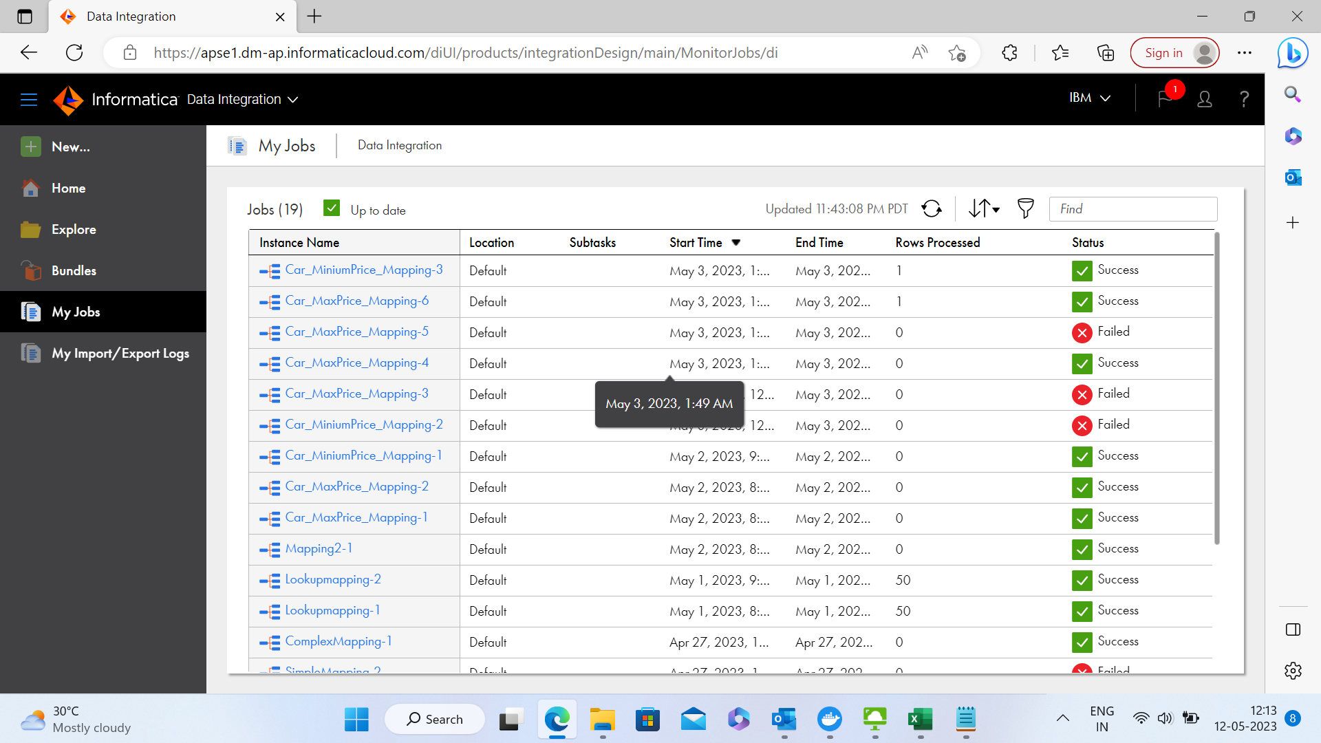

Informatica Project Activity 1

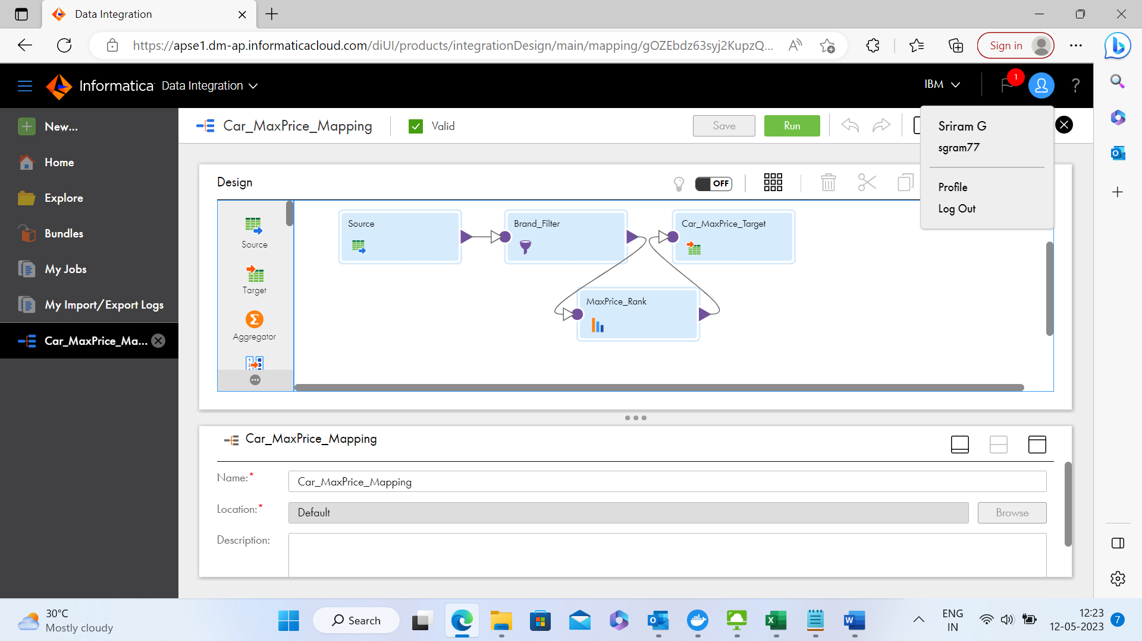

Informatica Project Activity 1

Project Activity 2

Result



Practicals

